2016-2017 Calendar
Nov. 18 Popcorn Day
Nov. 18 Norton Pines Family Night 5-8pm
Nov. 21 Picture Retakes
Nov. 23 End of 1st Marking Period
Nov. 23 Early Dismissal 11:01 am
Nov. 24-25 Thanksgiving Break—No School
Nov. 29 Parent/Teacher Conferences 3:30-6:30
Dec. 1 Parent/Teacher Conferences 4:00-7:00
Dec. 5-8 Vision/Hearing Screening
Dec. 8 Smiles Mobile Dentist Visit
Dec. 13-16 Santa’s Secret Shop
Dec. 15 1st&2nd Grade Christmas Program
Dec. 21 Christmas Break Begins
Jan. 3 School Resumes 7:40 am
Jan. 13 Norton Pines Family Night 5-8pm
Jan. 19 Early Dismissal 11:01 am
Jan. 20 Early Dismissal 11:01 am
Jan. 24 Family Skate Night at the Roller Fox 5:30-7:30 pm
Feb. 17 Early Dismissal 11:01 am
Feb. 20 Mid-Winter Break—No School
March 3 End of 2nd Marking Period
March 7 Parent/Teacher Conferences 3:30-6:30 pm
March 9 Parent/Teacher Conferences 4:00-7:00 pm
March 16 Kdg. Field Trip to Muskegon Lakeshore Museum
March 31 No School
April 3-7 Spring Break
April 10 School Resumes 7:40 am
April 12 4th Grade Frauenthal Concert
April 14 Early Dismissal 11:01 am
May 29 Memorial Day—No School
June 6 1st Grade Field Trip to Spring Lake Aquatic Center
June 8 Early Dismissal 11:01 am
June 9 Last Day Early Dismissal 11:01
Dear Parents,
Believe it or not, we are almost half way through November. I guess time flies when you’re having fun!!
The end of the first trimester is November 25th and conferences are quickly approaching. Parent-Teacher conferences are November 29th (3:30-6:30) and December 1st (4:00-7:00). Your child’s teacher has sent home a conference request form. If you did not receive one, please contact your child’s teacher. Exact conference times will be coming home next week. It is extremely important that we continue to maintain a strong connection between home and school.
As Michigan weather continues to transition from Fall to Winter, please remember to send your child with weather appropriate clothing. The students go outside for recess daily unless the weather is extreme.
Please continue to encourage your child to read daily. Research shows that young children who read or are read to at home at least four days a week are more likely to recognize letters and letter sounds, count to 20, write their own name, and read or pretend to read. Emergent readers are much more likely to become fluent readers by practicing daily.
We now have a new, updated Beechnau Elementary Facebook Page. Please make sure you choose the one with the “Building Bright Beginnings” logo. We will continue to update important information through this new page.
Thank you for your continued role in the education of all Beechnau students.
Randy Creed Principal
PICTURE RETAKES are on November 21. You must return the first packet in order to have retakes done.
Times to Know

7:40 a.m. Children may enter classrooms
7:50 a.m. Classes begin
11:01 a.m. Early dismissal
2:47 p.m. End of the School Day

DELAYS IN SCHOOL
When there is a two-hour delay, school will begin at 9:50 a.m. Morning Preschool will be cancelled for that day.

End of Day Dismissal
All bus-riding students are put on the bus at the end of each day unless parents have called to notify the office and bus garage. If you have a change in plans during the day, and would like to pick your child up from school, please call the office so we can let your child know that they will be picked up. Please call the office by 2:00 as it takes time to give all of the students their messages at the end of the day.

VOLUNTEERS!!!!!
Parent volunteers and visitors are always welcome at Beechnau Elementary. When you come into school, please stop at the office and pick up a visitor sticker.
If you plan to volunteer for field trips or classroom help please be sure you have filled out a background check and turn it in as soon as possible so there will be no delay in allowing you to help out at Beechnau.

Reminder . . .
Please label your child’s possessions (ie: hats, jackets, bags, lunch boxes). Young children seldom recognize lost items and many children have the same kinds of items. If you label things, maybe we can keep losses to a minimum.

Don’t forget to save your Box Tops and send them in to school. This is a great and easy fundraiser for our school. All of the money earned through the Box Tops program goes into the activity account that funds our field trips, assemblies, helps cover school supplies, and many other items. Since we only did one merchandise fundraiser this year our funds were cut more than in half. Box Tops is an easy way to fundraise for our school. You are purchasing items you already want and need and then you are able to give some of it right back to the school. Please continue to send them in along with Ravenna Food Receipts and your Spartan UPCs. CAMPBELLS IS NO LONGER DOING THE LABELS PROGRAM but they will honor any point labels sent in during this school year.

LOST AND FOUND! Our lost and found area is already growing. Please check it out to see if you have any items there!

STUDENT ABSENCES

If your child is absent for
any reason, please contact the school office at 231-853-2258 by 9 a.m. If the secretary is not in the office, or on the other line and you get sent to voicemail, please leave a detailed message with the child’s name, teacher’s name and reason for the absence. For example fever, vomiting, head cold, head-ache, and so
forth. If your child has a fever and/or vomiting, it is very important they stay home from school until they have been fever/vomiting free for AT LEAST 24 hours without the aid of medication. DO NOT send your child to school with a rash until your doctor has said it is safe to do so. If your child has been diagnosed with Pink Eye, Strep Throat, Fifth Disease, or any other disease/virus please inform the office immediately. As a school, we need to report to the health department on a weekly basis.
It is important that we know that your child is not going to be here for the day. If we do not hear from you by 9 a.m., we will call to make sure that your child is home with you. Please know that we are checking because we care about the safety of our students.

Medication Dispensing Rules
Medications can be available and given to students under the following conditions:
Over-the-counter medications will only be administered according to the manufacturers label for your child’s age/weight. A Non-Prescription Medication Permission Form must be filled out by the parent/guardian. Ifa greater amount of medication is needed then recommended by the manufacturer, a prescription or doctor’s note with the doctor’s signature is required.

ALL medication must be brought to school by an adult. DO NOT send medication to school with your student!!

Prescription medication can be administered at school. A Prescription Medication Permission form must be filled out by the parent/guardian AND a Physician Statement form with the physicians address and phone number.
- All medications must be in their original container with dosing instructions. NO baggies or envelopes will be accepted.
- If your child carries their albuterol and/or epinephrine pens, an Authorization for the Use and/or Possession of Asthma Inhalers, Epinepherine Injectors and/or Other Emergency Medications form must be completed and on file in the nurse’s office.
If you have any questions, please feel free to give me, Vickie DeSmith – School Nurse a call or leave a message at 853-2258 ext. 1303.

RPS Head Lice Policy

If a student is found to have head lice, they will need to be checked by the Nurse or a designated staff person and found free of lice or nits (lice eggs) before being allowed back into class. They will need to be brought to school by an adult, who is asked to stay until after the student’s head is checked and found clean of lice or nits. This procedure will be followed until no lice or nits are found. Here is also a link to the head lice information from the State of Michigan:

www.michigan.gov/documents/Final_Michigan_ Head_Lice_Manual_106828_7. A registered nurse is at Beechnau Elemantary part-time. Parents who have questions regarding health problems that may affect the school are encouraged to call the nurse, 231-853-2258 ext. 1303.

PARENT CLUB NEWS

We held our October meeting on the 26th and we had a very productive night. Mr. Creed gave us information on the BE NICE program that Beechnau has adopted. Shirts and wrist bracelets were made available for sale and the order has been placed.

We will once again be doing monthly snacks for the staff. Each grade level covers a month during the school year. The snacks will be brought in on the LAST THURSDAY OF THE MONTH. Following are the assigned months and the contact person.

November: Third Grade: Cathy Emery
January: Second Grade: Stephanie Ford
February: First Grade: Amanda Faino
March: Kindergarten: Sarah Klooster
April: Preschool
May: Parent Club

A great big THANK YOU to the fourth grade parents who provided snacks for the staff for the month of October. They were greatly appreciated!

Box Tops, Ravenna Foods Receipts, and Spartan Labels are continuing to be collected. CAMPBELLS IS NO LONGER PARTICIPATING BUT IF YOU HAVE THE POINTS LABELS SAVED SEND THEM IN AND THEY WILL BE HONORED FOR THIS SCHOOL YEAR ONLY. Send them in as you gather them. They are turned in by the Parent Club and we receive a check that is used to buy things for our Beechnau students. Amy Leutzinger or Lisa McCabe are the contacts if you are interested in helping with this.

Popcorn Fridays continue to be a favorite of the students. Our next popcorn Friday will be Nov. 18th. We are in need of more volunteers for popping so if you are interested please see Stephanie Ford.

Our next meeting will be held on November 30th at 6:45 p.m. in the cafeteria.

We will be having a monthly contest for the highest number of Box Tops that are turned in by class. The winning class will have an extra recess! Keep saving and turning them in to your child’s classroom!

SANTA’S SECRET SHOP will be held on DECEMBER 13th through DECEMBER 16th. We have contracted with a new company called FunServices, a division of World’s Finest Chocolates.

PARENT-TEACHER CONFERENCES will be happening on Tuesday, Nov. 29th and Thursday, Dec. 1st. They will run from 3:30 to 6:30 on Tuesday, and from 4:00 to 7:00 on Thursday. Papers have gone home with students. If you have not received one please contact your child’s teacher for a form.

FROM THE TRANSPORTATION DEPARTMENT:

INCLEMENT WEATHER:

The question that is often asked is “How do we determine cancellations or delays?” There is a lengthy process that we follow in making this determination.
- Both the Transportation Director and Superintendent monitor news and weather service forecasts prior to the school day.

- Transportation Director is on the road checking/monitoring conditions no later that 4:00 a.m.

- Transportation Director contacts area Transportation Directors from Coopersville, Fruitport, Oakridge, Kent City and Grant which border our school district. Transportation also monitors the county wide radio channel for all of Muskegon County schools for reports of cancellations or delays.

- Transportation Director may contact the Maintenance Director on his findings of road conditions and how plowing etc. is going.

- Once all data to make a decision is collected, the Transportation Director contacts the Superintendent of schools and makes a recommendation or consults the Superintendent to make a final decision.

- Once the decision is made local news media, radio stations, and School Messenger will notify the public of the decision of a cancellation or delay to our school day.

Safety of our students and staff are always considered in making a school closing decision. Safety is our #1 priority at all times! If you have any further questions pleasecontact the Transportation Department at 853-6311.

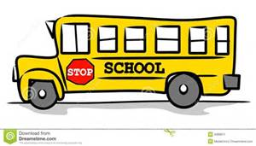

NOW HIRING!!! Become a SCHOOL BUS DRIVER! METS, the transportation employer for Ravenna Public Schools is currently hiring school bus drivers for part time assignments starting at $15 per hour. No experience is necessary and training will be provided to qualified candidates. Apply today by sending your resume to recruiting@contract busdrivers.com. For more information, please call (231) 853-6311, or toll free at (888) 996-8586.

Book Fair Treasure Hunt
The classes are involved in a penny war to earn a chance of winning a treasure trove of books for their classroom library. Gather up your pennies and send them in with your child to put into the pirate jug. The coins will be counted and the progress will be charted by moving their ships on the wall outside the library. As they move they will move closer to the treasure. Once the “X” is reached the winning grade will be able to get the treasure of new books!

BIG CRUNCH! On Thursday, Oct. 13 Beechnau celebrated the Big Crunch! We had all students Preschool to 4th grade, along with the staff crunching their apples at 1:21 p.m. to help promote making healthy snack choices!

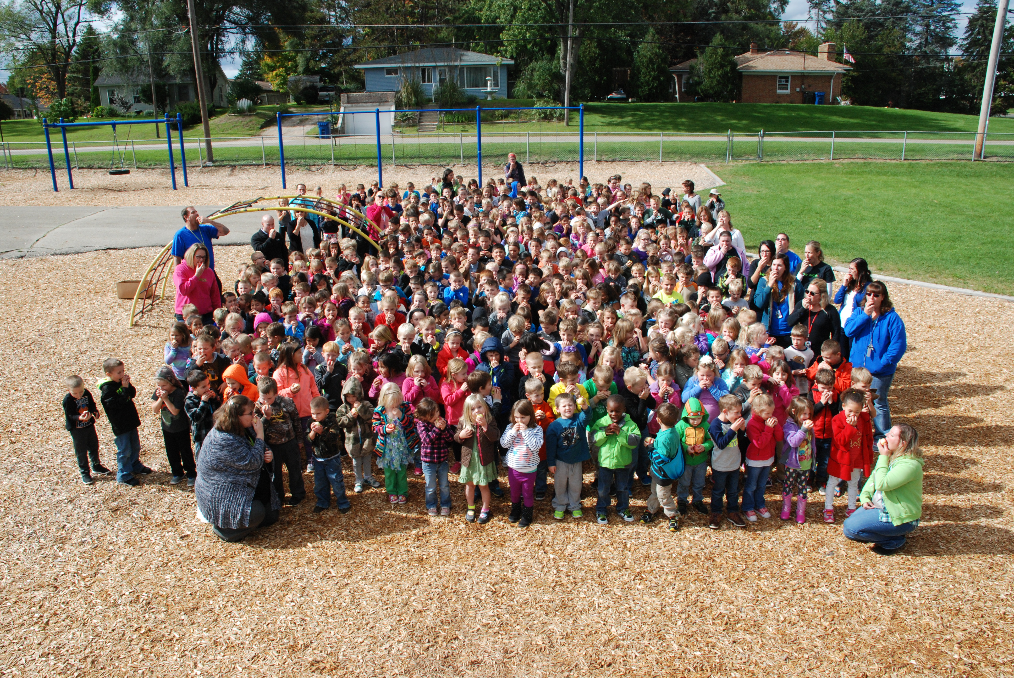

Principal Pals

CORBIN WION for doing well on K-PALS.

LAUREN SIEBELINK for having an excellent attitude!

BENTLEY WETMORE for doing his work very neatly!

JOHNATHON YANEZ for getting along with everyone and having a great attitude!

ZAYNE PATTYN for being a hard worker.

KARRSEN PORTER for doing a great job and following the rules.

SEPTEMBER STUDENTS OF THE MONTH:

KDG: Celia Walker
Casen Rupe
Easton Skuse
Joslyn Nutt

1st Grade: Mikey Faino
Alyssa Randolph
Brady Karchinski

2nd Grade: James Korson
Seth Kantola
Kodi Hackenberg

3rd Grade: Dylan May
Brinley Kieft

4th Grade: Brenna Walker
Blake Douglas

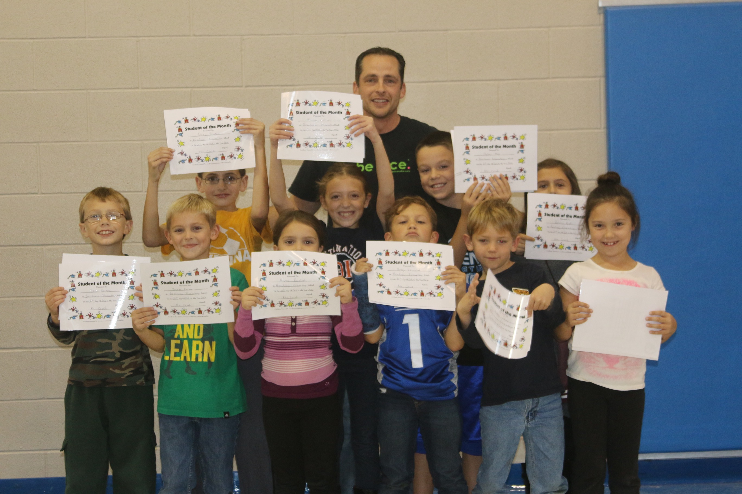

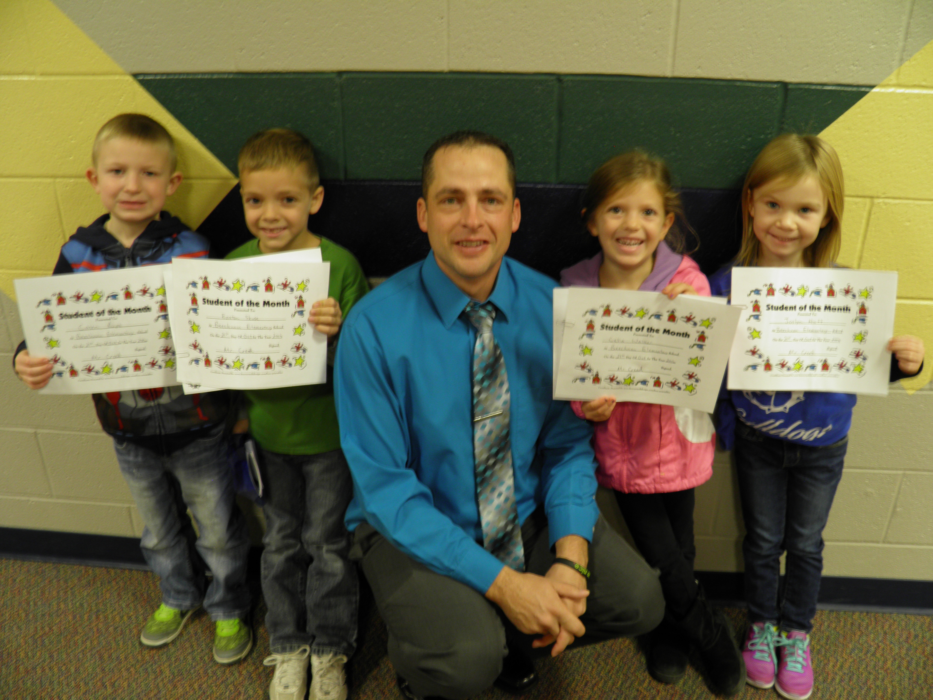
BEECHNAU PUMPKIN CONTEST WINNERS: There were over 50 entries for the pumpkin contest this year. There was a lot of smiles and excitement as we watched them all come in. Judging by our panel was extremely difficult. They all said they were amazed by the creativity they saw in the entries! Below are the judge’s picks as winners.

PRESCHOOL:
1st Place Tie: Maggie Fialek
Levi Luce

KINDERGARTEN:
1ST Place: Marlee Wilburn
2nd Place: Emelyn Stein
3rd Place Tie: Sophie Robinson
Alayna Russell

FIRST GRADE:
1ST Place: Peighton Bonk
2nd Place Tie: Ethan Deal
Kate Solem
3rd Place: Cole Raymond

SECOND GRADE:
1ST Place Tie: Jaxson Wilburn
Taylor MacKeller
2nd Place: Evelyn Russell
3rd Place: Taylor Nutt

THIRD GRADE:
1st Place Tie: Brinley Kieft
Raelyn Olsen
2nd Place: Macy Nelson
3rd Place: Cameron Patterson

FOURTH GRADE:
1st Place: Nadia Luce
2nd Place: Brooklyn Jebb
3rd Place Tie: Mattisen Crowley
Wayland Austin
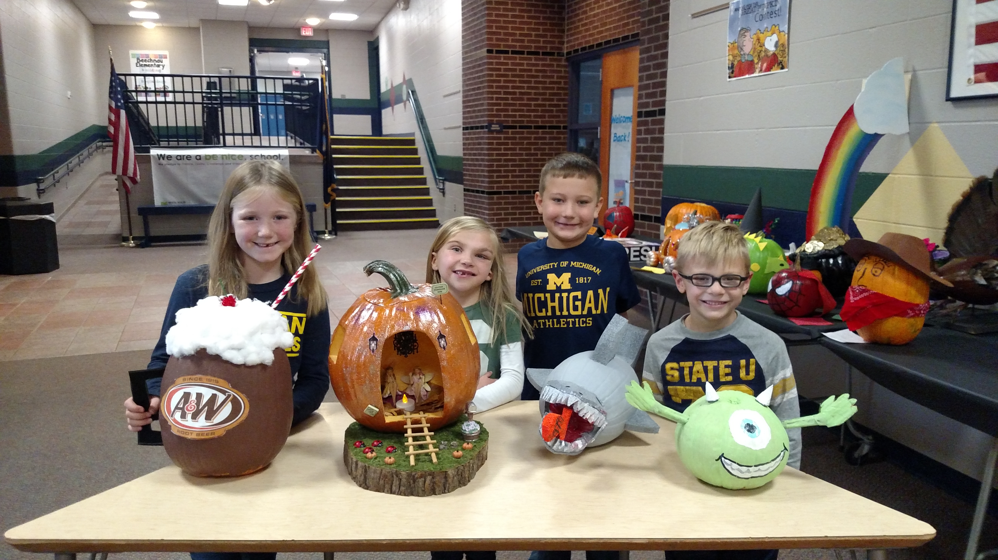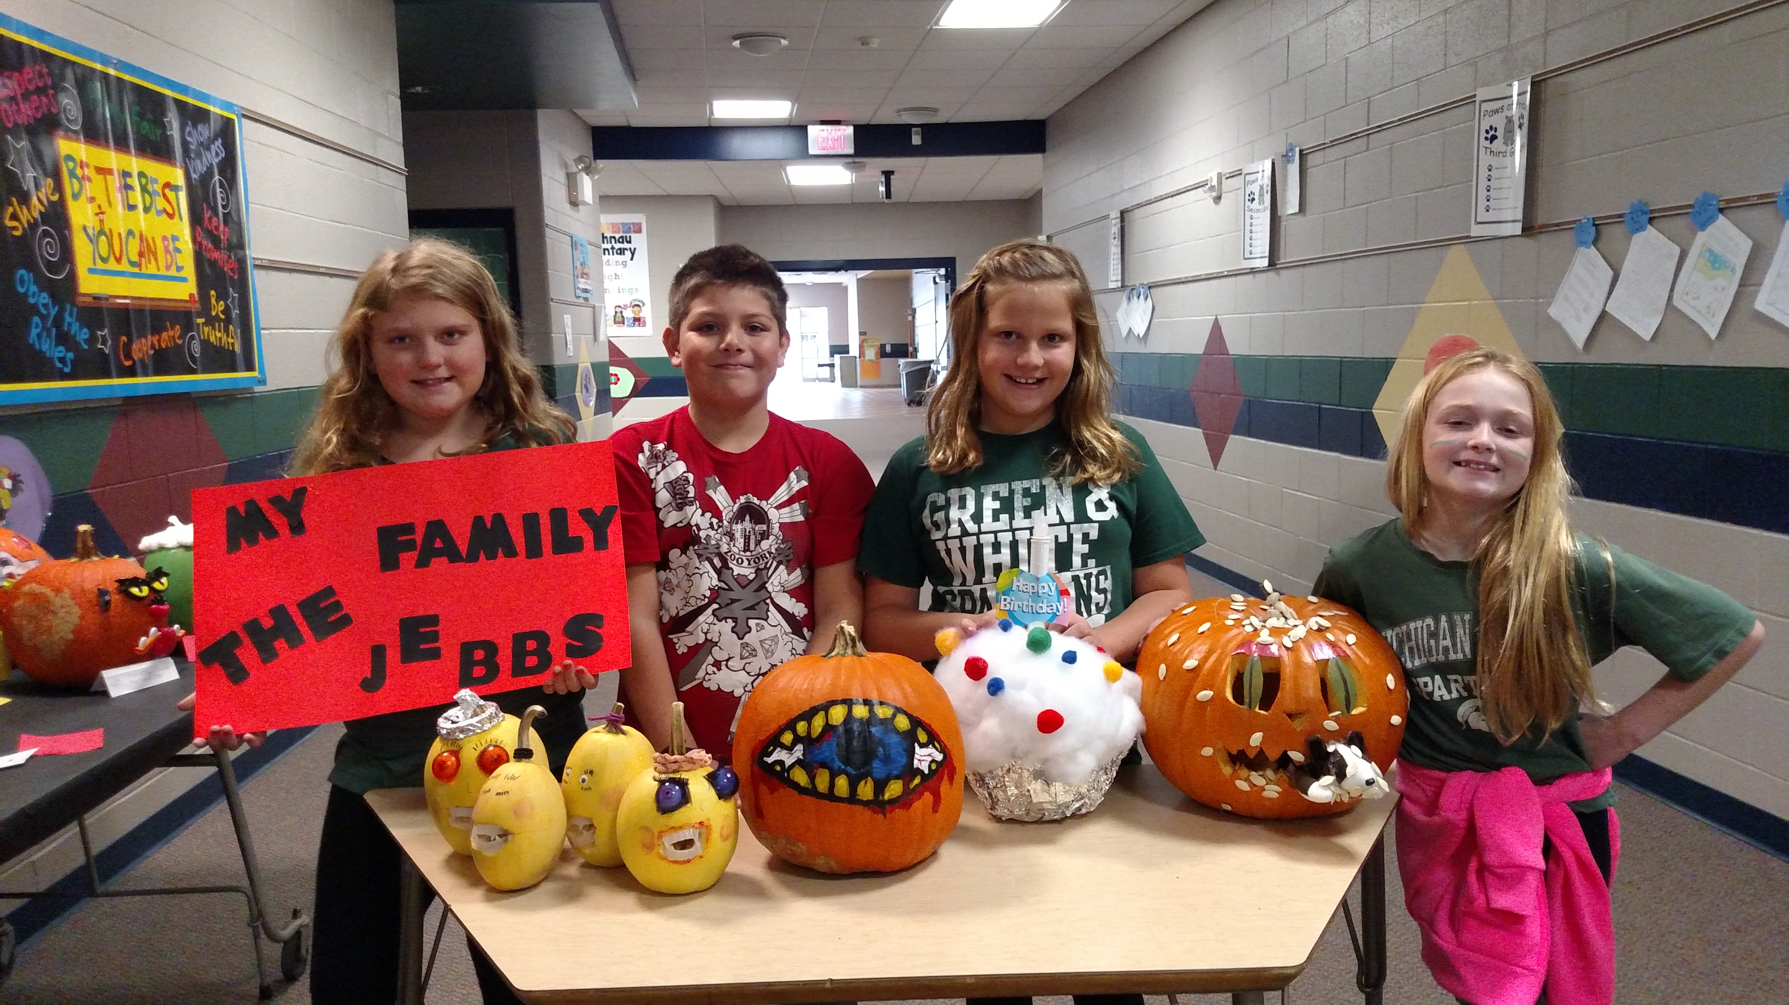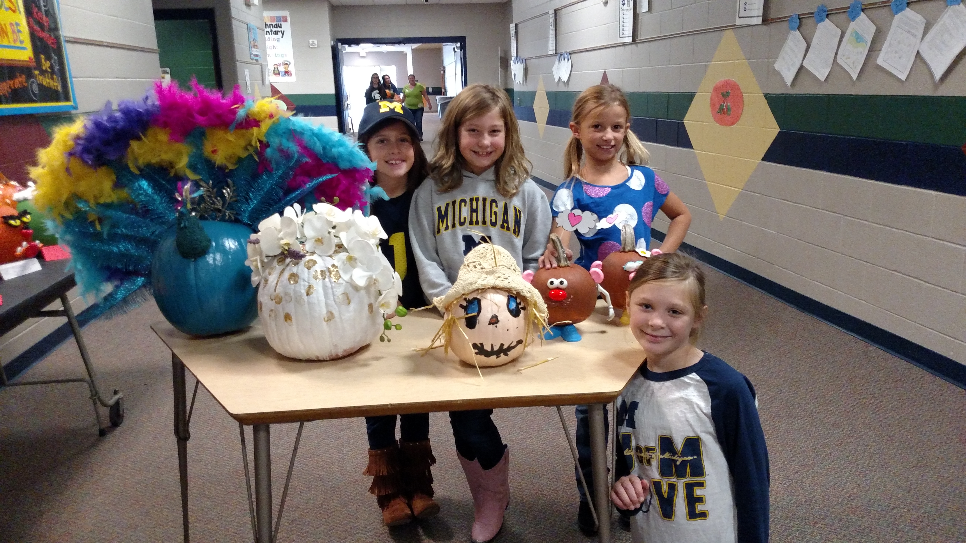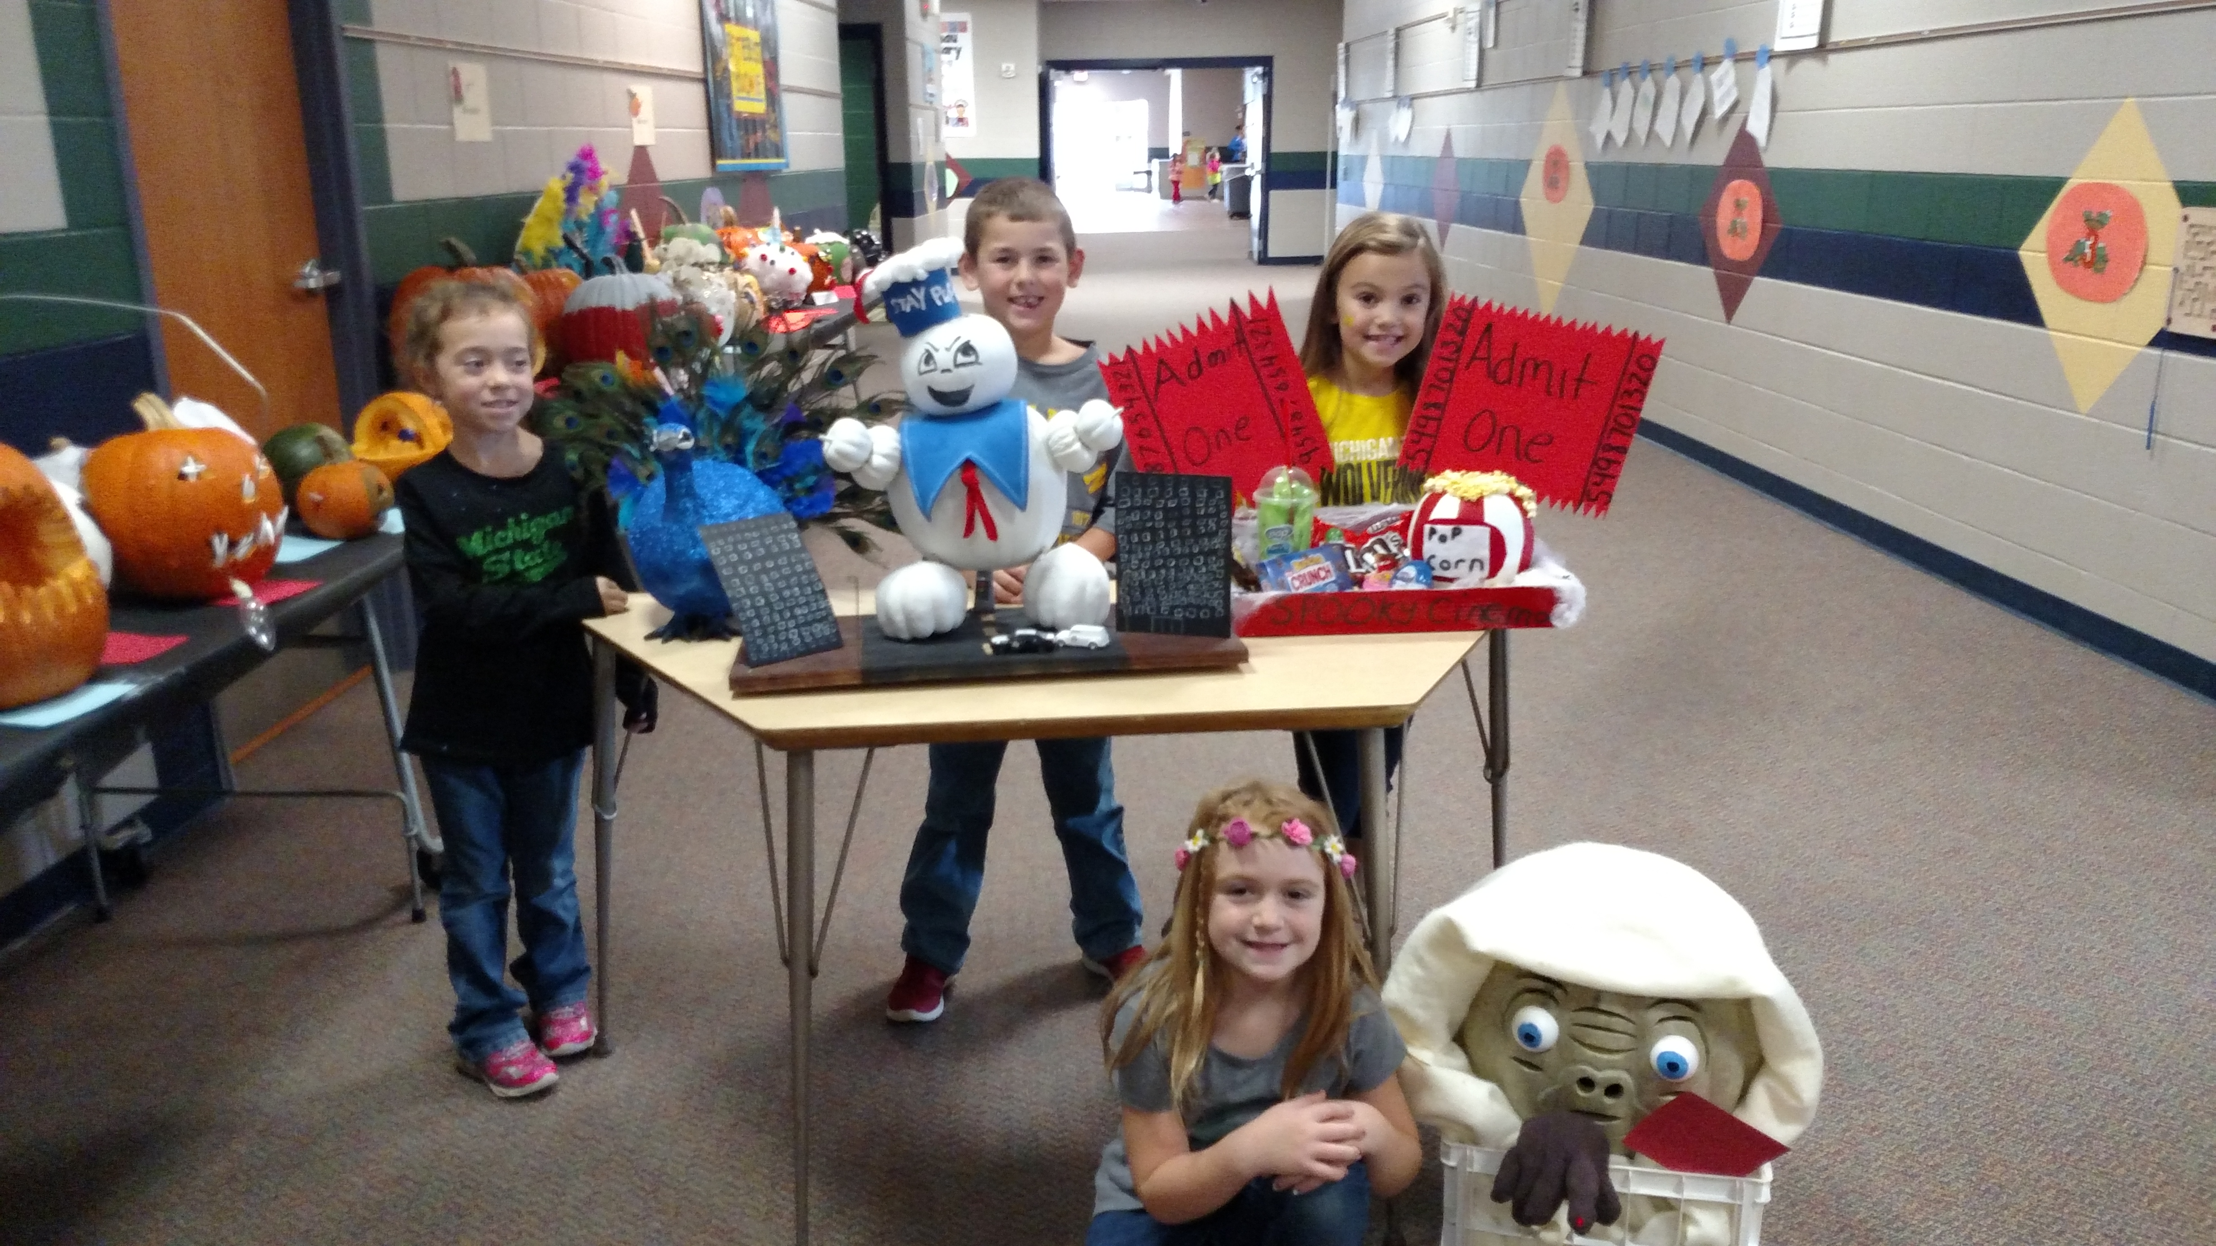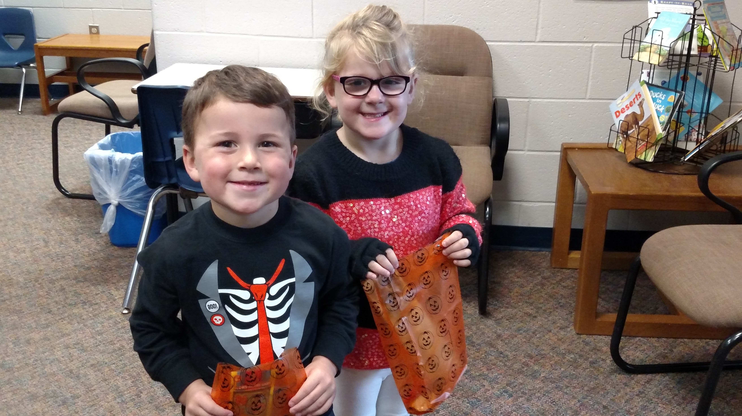

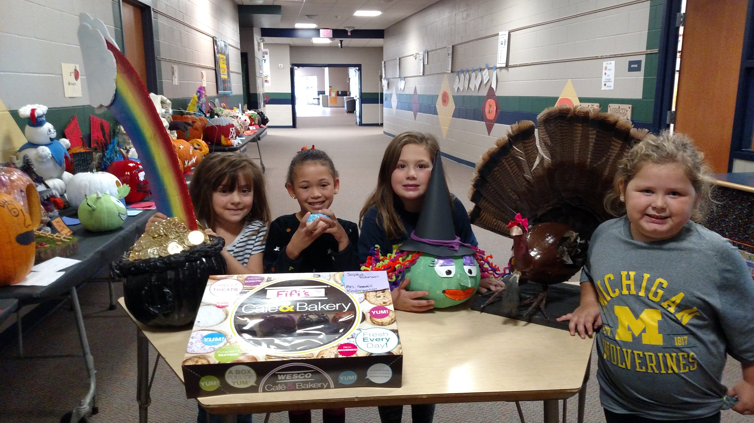

LOVE CONNECTION IS COMING!

Beechnau students will once again be collecting non-perishable food items and new unwrapped toys for Love Connection. All food and toys will be distributed by the Lions Club to needy families in Ravenna.

We are having a class contest to see which class brings in the most items. Our theme this year is “How Sweet It Is To Share”, and we will have a gingerbread display outside the office tracking donations. Every item brought in will earn a point for the class. The class with the most points will win a pizza party!

Thank you in advance for helping out others in our community who may need it this holiday season.

MARK YOUR CALENDARS

November 18: Norton Pines Family Night 5:00 to 8:00 pm

November 21: Picture Retakes

November 23: 1/2 day for Thanksgiving Break.

November 24/25: Thanksgiving Break No School

November 29: Parent/Teacher Conferences 3:30-6:30 pm

December 1: Parent/Teacher Conferences 4:00-7:00 pm

December 8: Smiles Dentist Visit

December 15: 1st/2nd Grade Christmas Program 6:30 pm

December 21: Christmas Break Begins

