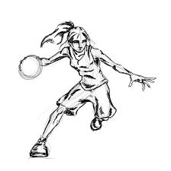

RAVENNA GIRLS BASKETBALL YOUTH CAMP
JUNE 27-30
At the High School Gymnasium
Cost: $10
Directed by Ravenna Girls Basketball Coaches Steffen Halvorsen and Brandi Emory and current basketball athletes.

- Individualized attention and instruction
- Fundamental Skill Development: Dribbling, Shooting, Passing, Defense
and so much more!
- All campers will receive a T-Shirt

Any questions can be directed to Steffen Halvorsen at (231)903-1831 or emailed to coachhalvorsen@yahoo.com

Make checks payable to ‘Ravenna Girls Basketball’. Include participants name on all checks. Completed forms and checks can be mailed to:

Steffen Halvorsen, 1056 S. Maple Island Rd., Muskegon, MI 49442

- 1st & 2nd Grades: 5:00 – 6:00 p.m.
- 3rd, 4th, 5th Grades: 6:10 – 7:10 p.m.
- 6th, 7th, 8th Grades: 7:20 – 8:30 p.m.
- - - - - - - - - - - - - - - - - - - - - - - - - - - - - - - - - - - - - - - - - - - - - - - - - - - - - - - - -

Participants Name:_______________________________ Age/Grade:_________/________

Address: __________________________________________________ T-Shirt Size:______

Phone Number:_______________________ Insurance Provider:_______________________

Parent/Guardian Name (Please Print):______________________________________________

I, __________________________________ hereby aurthorize the director of the camp to act

accordingly to their best judgement in the event of a medical emergency. (Parent/Guardian

signature required)

